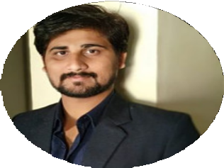

RAHUL PAWAR

DIGITAL MARKETING EXECUTIVE

# P E R S O N A L P R O F I L E

**W O R K E X P E R I E N C E**

Digital Marketing Expert

Genome Groups

April 2019 - Present 4 Months Contract

Manage social media planning & presence Website structure planning

Sales and online marketing strategy

Product packaging design strategy

Digital Marketing Executive

SME Joinup Pvt.Ltd

Oct 2017 - Mar 2019

Facebook paid marketing Search Engine Optimization

Manage social media planning & presence Landing page creation

Whiteboard and Animation Video Designing Create and Execute Email Marketing Campaigns Database creation for email marketing

Google Ads Campaign Creation Train Interns

Client Handling

Digital Marketing Intern

SME Joinup Pvt.Ltd

Jul 2017 - Sept 2017

On page Optimization for Keywords Keyword analysis and Competitor analysis Check Google Analytics and Webmaster tool Keyword Research & Competitor Research

Combine diﬀerent elements of my education, experience, and personality to contribute to the world of business to achieve the desired growth.

# S K I L L S

Social Media Marketing Email Marketing

SEM SEO

Video Marketing Animation Video Designing

# T O O L S

Google Analytics Webmaster Google Ads

Facebook Business Manager Mailchimp

Leadsquared Canva Vyond

Spyfu

# I N D U S T R I E S E D U C A T I O N

Real Estate Healthcare Tourism

IT

Health & Fitness Accounts and Finance FMCG

# C O N T A C T

## B.Tech [E&TC

Dr. Babasaheb Ambedkar Technological University 2*010 – 2015*

## HSC

Yeshwantrao Chavan College

### *2008 – 2010*

**SSC**

Sant Janabai Vidyalay

### *2007 – 2008*

 Sukhawani residency, Dapodi,

Pune

 [p.rahul8855@gmail.com](mailto:p.rahul8855@gmail.com) 8855817755/8668891660

/rahulpawar8855

STRENGTHS

Quick and self learner Self Motivated Positive thinker Creativity

Flexible